Assignment 2 University of Central Punjab
NAME: Muhammad Imran Butt
Reg no: L1F24BSCS0546

Total Marks: 20 Submission Date: 07/11/2025
Topics Covered: Data Types, Variable Declaration, ALU Operations, Arrays & Loops, Addressing Modes
Q1. Coding Task – ALU Operations and Variables (10Marks)
Write an 8086 assembly language program to:
- Declare two byte variables, NUM1 and NUM2, initialized with values 25H and 15H.
- Perform the following operations using ALU instructions:
  - Add the two numbers and store result in SUM.
  - Subtract NUM2 from NUM1 and store result in DIFF.
- Display both results using the register indirect addressing method.
(Hint: Use MOV, ADD, SUB instructions and memory variables.)
ANSWER:
CODE:
.model small
.stack 100h
.data
NUM1 DB 25H
NUM2 DB 15H
SUM DB 0
DIFF DB 0
.CODE
MOV AX,@DATA
MOV DS,AX
MOV DL,[NUM1]
ADD DL,[NUM2]
MOV [SUM],DL
MOV DL,[NUM1]
SUB DL,[NUM2]
MOV [DIFF],DL
MOV BX, OFFSET SUM
MOV AH,0H
MOV AL,[BX] ;SUM
MOV BX,OFFSET DIFF
MOV DL,[BX];DIFFERENCE
.EXIT
SCREENSHOT:
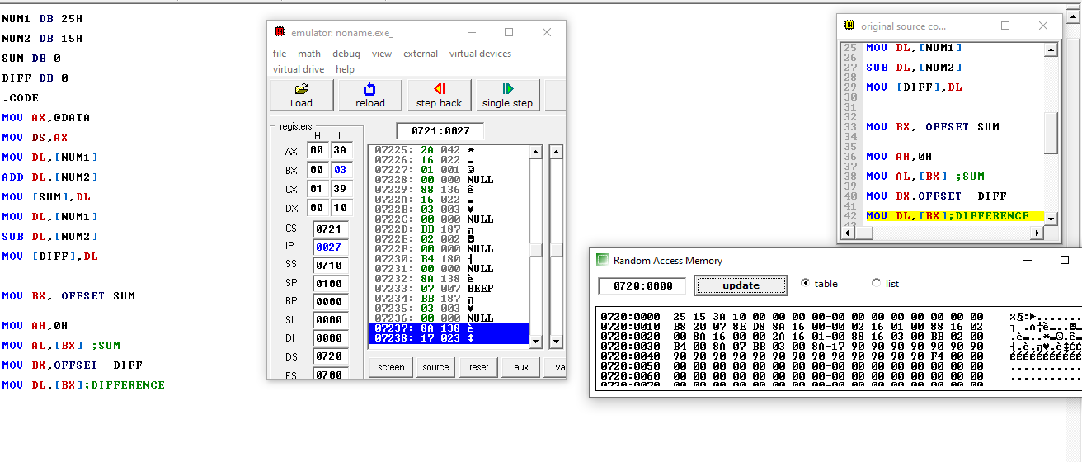
NUM1 NUM2 SUM DIFF

Q2. Coding Task – Arrays and Loops (10Marks)
Write an assembly program that:
- Declares an array of 5 elements (word type).
- Uses a label and LOOP instruction to:
  - Multiply each element by 2 and store it in the same array.
- Access array elements using Base + Index addressing mode.
- Finally, print all elements to verify results.
(Hint: Use SI, BX, and LOOP instruction effectively.)

CODE:

.MODEL SMALL

.DATA

ARR DW 1001,2002,3003,4004,5004

.CODE
MOV AX,@DATA
MOV DS, AX
MOV CX,5
MOV SI,0
MOV DI,0
MOV BX, OFFSET ARR
MY_LOOP:
MOV AX,2; TO MULTIPY (MULTIPIER)
MOV DI,[BX + SI]
MUL DI
MOV [BX + SI],AX
ADD SI,2
LOOP MY_LOOP
.EXIT

